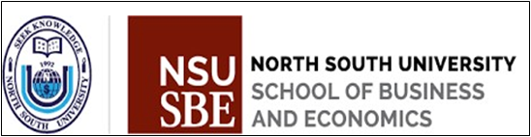

**Course:** Fin 464 (Bank Management & Financial Services)

**Group Project Report**

Prepared For-

Abdullah Al Mamun (AHM)

Lecturer, Department of Accounting and Finance, School of Business and Economics,

North South University

Section: 3

Prepared By-

|  |  |
| --- | --- |
| NAME | ID |
| Ayesha Momtaz Maliha | 2012640030 |
| Wasif Mohammad khan | 1831566630 |
| Reina Ahmed | 1911734630 |
| Muntaha Mostofa | 2011999630 |

Date**:** 20 June, 2023

Report On

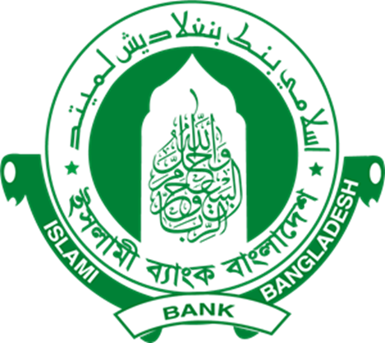

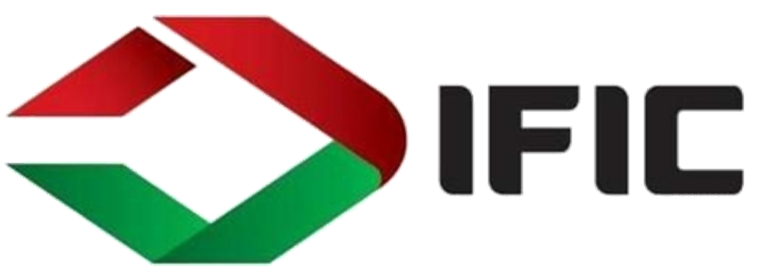

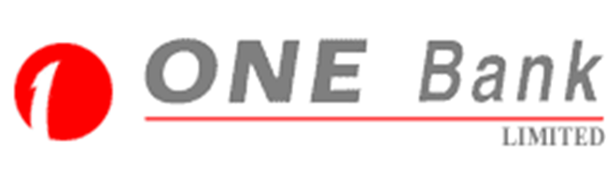

**Liquidity Ratio**

|  |  |  |  |
| --- | --- | --- | --- |
|  | **ISLAMI Bank** | **IFIC Bank** | **ONE Bank** |
| Year | 2022 | 2022 | 2022 |
| Current Ratio | 0.17 | 1.64 | 0.19 |
| Quick Ratio | 0.19 | 0.012 | 0.065 |

Current Ratio

Here we can see that in 2022, IFIC Bank has the highest current ratio compared to ISLAMI and ONE bank. Both ISLAMI AND ONE Bank is holding the 2nd position. That means that ONE Bank and ISLAMI Bank should increase their short-term asset to balance their liabilities. IFIC bank has good current ratio which indicates they have sufficient short-term assets to back up it’s short-term liabilities.

Quick Ratio

The quick ratio scenario isn’t favorable for either of the banks. The ratios of that particular year for the ISLAMI Bank, IFIC Bank, One Bank are .19,.012,.065. Both, ONE Bank and IFIC Bank has failed to maintain a quick ratio that is close to the amount that is generally maintained by the banks which shows that they are unable to pay off their very short-term liabilities with very short-term assets. The scenario is slightly positive for ISLAMI Bank. That's mean ISLAMI Bank is holding more efficiency to back up their very short-term liabilities with their short-term assets., than ONE and IFIC Bank.

**Financial Risk Ratios**

|  |  |  |  |
| --- | --- | --- | --- |
|  | **ISLAMI Bank** | **IFIC Bank** | **ONE Bank** |
| Year | 2022 | 2022 | 2022 |
| Debt Ratio | 96.2% | 93.5% | 94.2% |
| Debt to Equity Ratio | 25.43% | 14.47% | 16.13% |

Debt Ratio

In 2022, the highest Debt Ratio was 96.2% for ISLAMI Bank. Along with 94.4% for ONE Bank and 93.31% for IFIC Bank. So it can be said that there is a big amount of debt in these three Banks' assets. The banks should pay attention to pay off their liabilities. Otherwise they can loose investors.

Debt to Equity Ratio

The highest debt to equity ratio position was held by ISLAMI bank at over 20%. Both IFIC and ONE bank had their ratios at around 16% or less. Therefore, ISLAMI Bank has a high debt compared to other banks, which can be risky.

**Profitability**

|  |  |  |  |
| --- | --- | --- | --- |
|  | **ISLAMI Bank** | **IFIC Bank** | **ONE Bank** |
|  | 2022 | 2022 | 2022 |
| Net Profit Margin | 13.33% | 9.7% | 22.06% |
| Net Operating Margin | 14.39% | 42% | 62.202% |
| Earnings Per Share (EPS) | 2.88 | 1.66 | 1.59 |
| ROA | 30% | 10.38% | 27% |
| ROE | 7.19% | 10.24% | 8.27% |

Net Profit Margin

Here in the table, we can that, ISLAMI Bank and ONE Bank are in a good position above 10%, where IFIC’s net profit margin ratio is 9.70% and is close to 10%.. Increasing profit and lower expenses will increase the net profit margin. ISLAMI Bank & IFIC Bank should increase their net income or they should reduce their expenses.

Net Operating Margin

Here, IFIC and ONE bank has a really high operating margin which means both banks are making a lot of profit. But ISLAMI bank has around 14.39%, which is low compared to others. ISLAMI Bank should look into their expense section.

Earnings per Share (EPS)

In 2022, ISLAMI, IFIC, and One Bank’s EPS were 2.88, 1.66, and 1.59, respectively. That means they are capable of earning against 1 stock respectively 2.88, 1.66, and 1.59. Any potential investors want to look EPS and compare with their competitors. Investors seek for greater value of EPS. Because they can get higher expected divided by this. Here ISLAMI Bank carried greater one.

Return on Total Asset (ROA)

In 2021, ISLAMI bank the highest ROA ratio with 30% rather than IFIC & ONE. Amount of profit they are able to make utilization of total assets. However, ONE Bank’s ROA is 27% which is higher than IFIC Bank which is 10.38%. Investor are seeking for higher ROA before investing.

Return on Equity (ROE)

ISLAMI BANK< IFIC % ONE bank’s ROE are respectively 7.19%, 10.24%, 8.27%. That means IFIC utilized owner’s invested money in generation of net income. Whenever investors are outing money, they are interest to know if the institutions is earning sufficient money out of their invested money. ISLAMI & One bank should increase their ROE. IFIC’s high ROE is attractive.

**Recommendation**

The operational profit margin of ISLAMI Bank was insufficient, in terms of profitability. So, we recommend that it need to be increased and effectively used. They can enhance the balance of deposits and loans through stronger management procedures. They must invest depositors' money successfully by efficiently employing resources. Aside from that, One Bank's return on assets (ROA) has to be increased. An increase in assets that do not generate as much revenue results in a decreased ROA. Almost all the banks have a high debt ratio. It indicates that a bank is highly leveraged, which can be risky for a bank. So decreasing the debt ratio should be a target for all three of the banks.

**Reference**

* <https://www.onebank.com.bd/>
* <https://www.islamibankbd.com/financial-report>
* <https://www.ificbank.com.bd/financial-statements>

**Appendix**

